**Try and Catch Block**

**\*Single Try and Catch blocks**

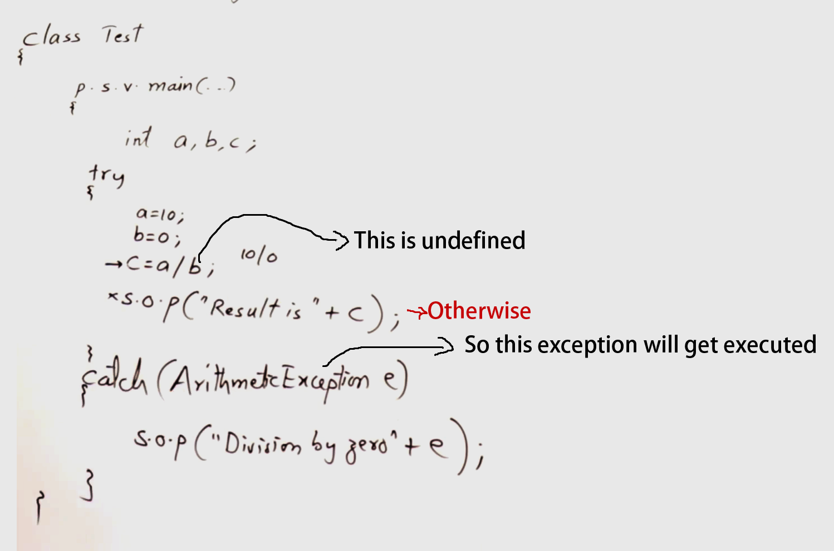

So if there is an error or exception it will go to **catch block** otherwise **try block** will get executed

**\*Multi catch blocks:**

If in Try Block there is more than 1 exceptions are possible then we can catch block for each exception

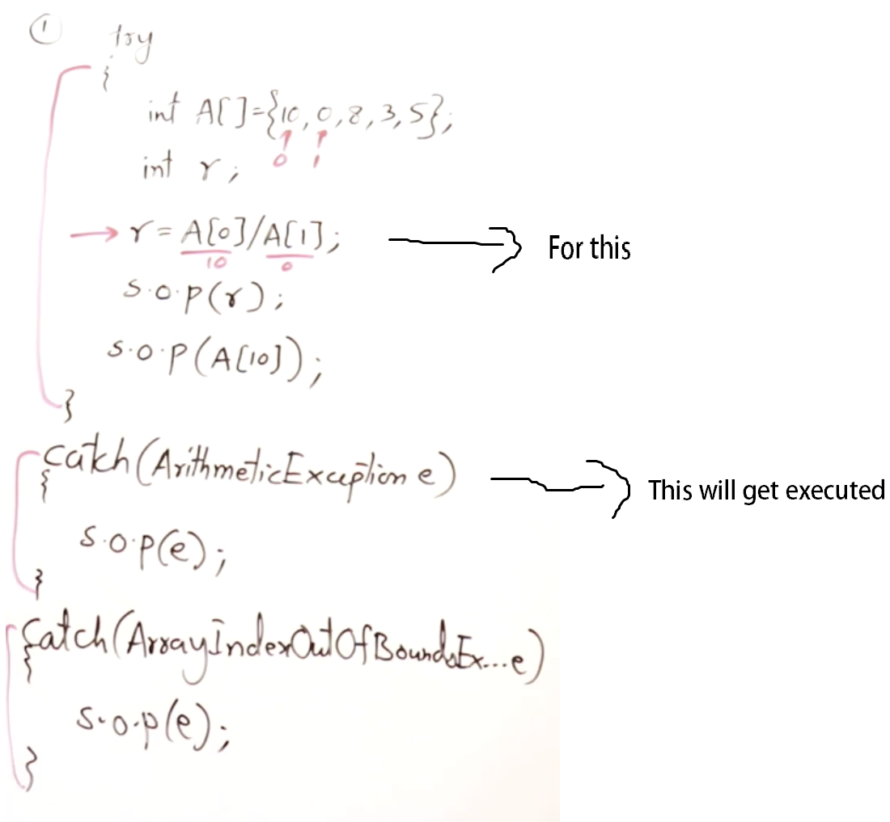

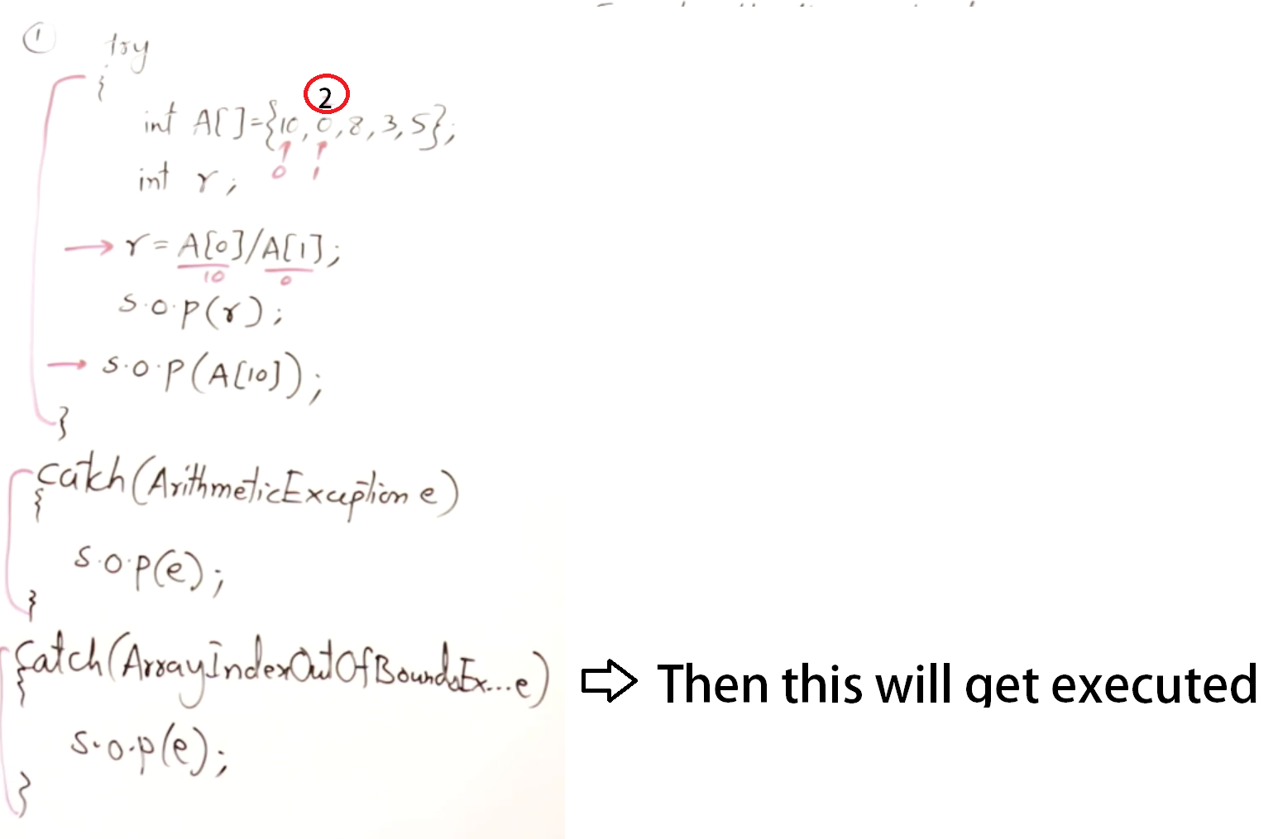

Keep remember that:

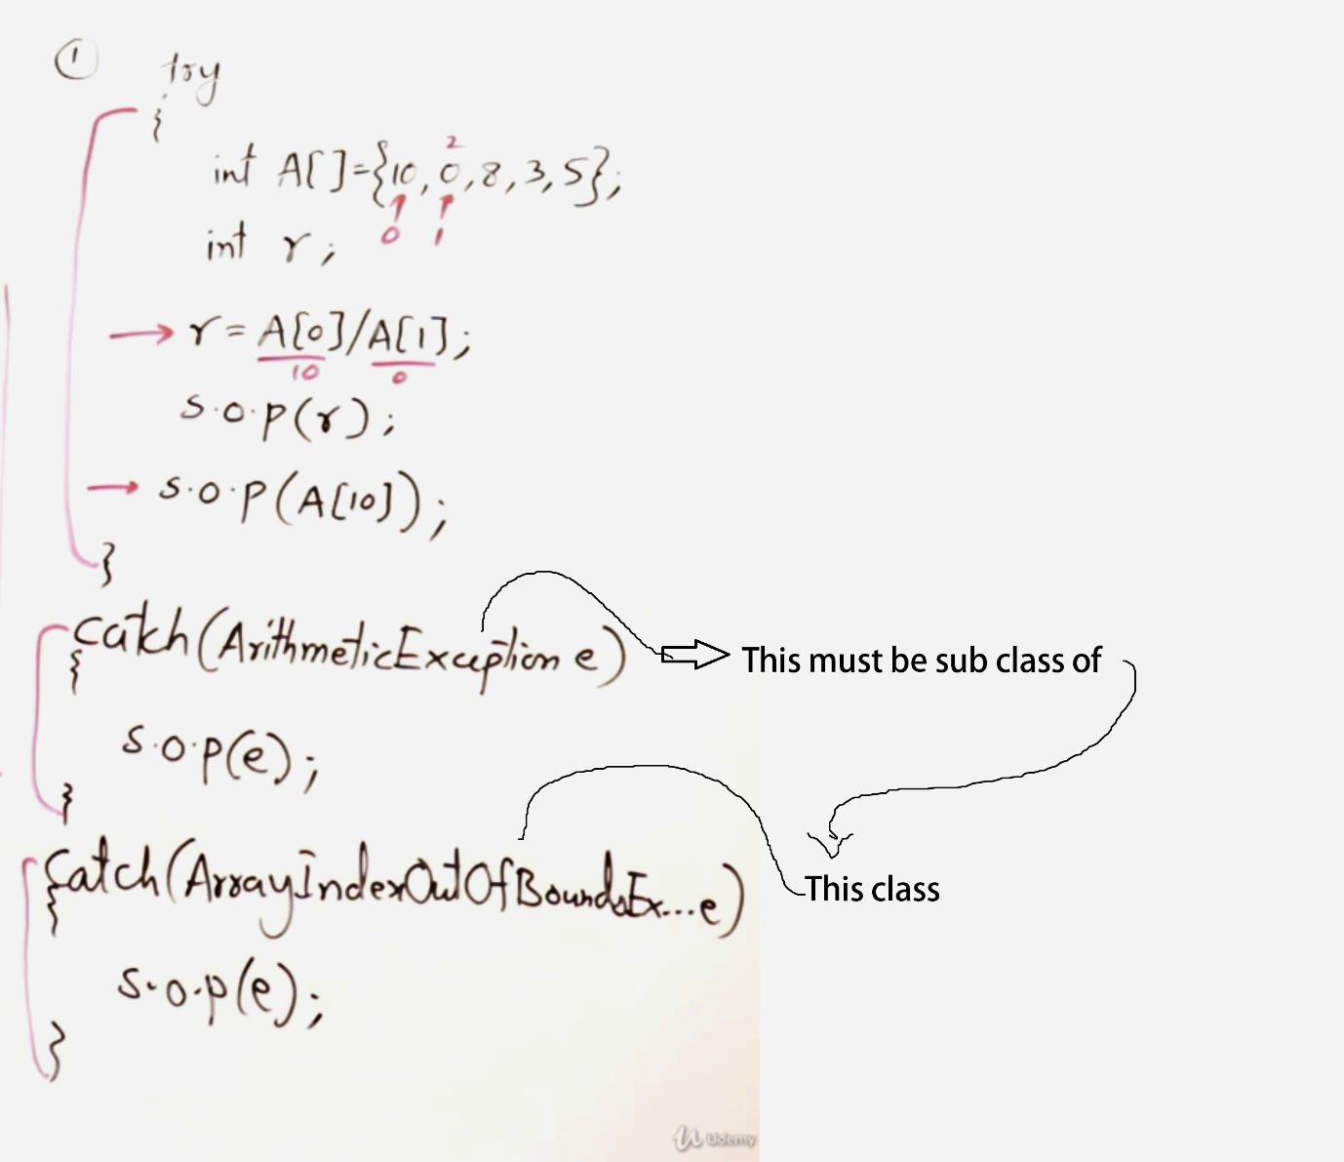

If (ArithmeticExeception e) is super class then it will shadow or hide (ArrayIndexOutOfBoundException e) catch block

**\*Nested Try and Catch blocks:**

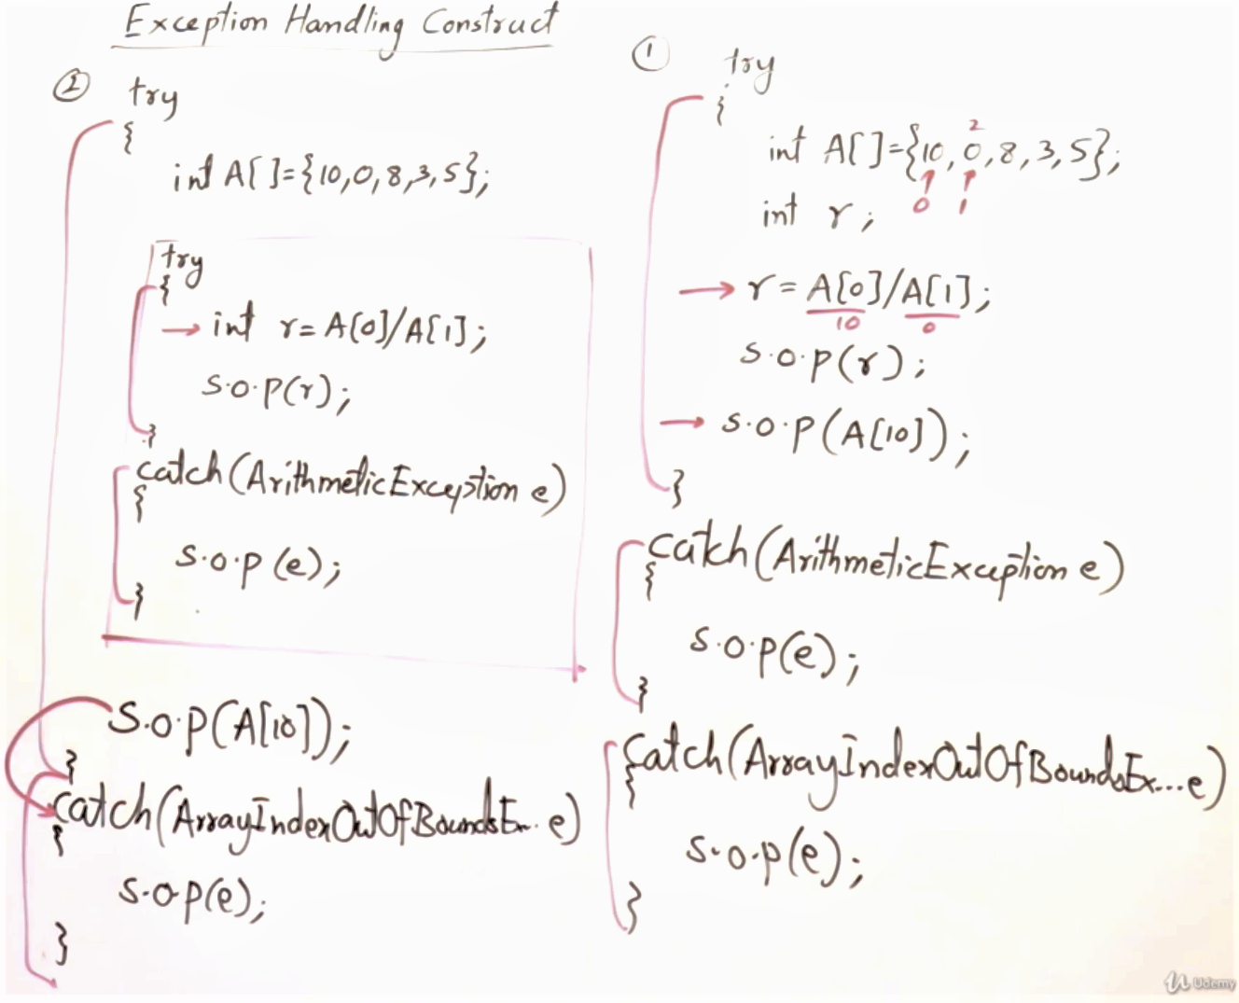

**\*Finally**

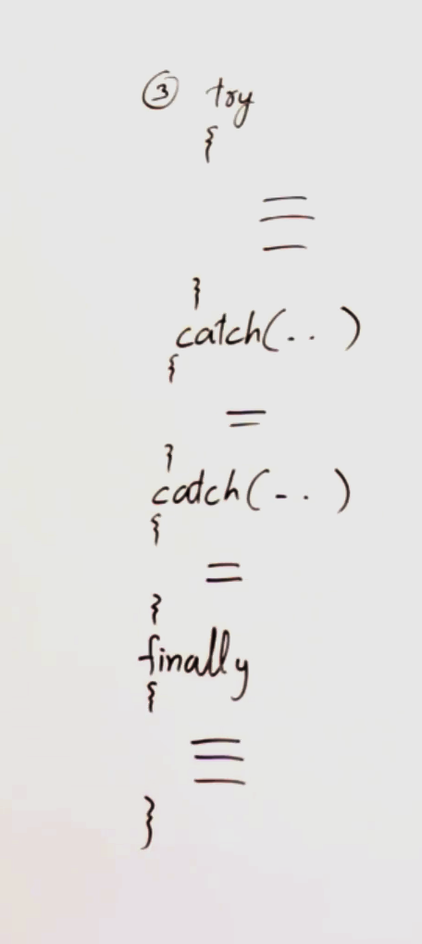

We can have a block finally at the end of catch block

Or without **catch** we can have **finally.**

**Try** block can also have **finally** block but it’s optional

Use:

**finally** block definitely gets executed weather there is a exception or no exception